Quelle: https://uncutnews.ch/neue-bilder-von-james-webb-sorgen-fuer-panik-unter-kosmologen-was-ist-da-los/

Neue Bilder von James Webb sorgen für Panik unter Kosmologen – was ist da los?
August 29, 2022

Anfang dieses Jahres erreichte das neue James Webb-Weltraumteleskop seinen endgültigen Bestimmungsort, von dem aus es in den nächsten Jahrzehnten das Universum beobachten soll. Das James Webb ist der Nachfolger des berühmten Weltraumteleskops Hubble, das seit 1990 in Betrieb ist.
Das Teleskop soll unter anderem Spuren des Urknalls aufspüren. Es kann eine Milliarde Jahre weiter sehen als Hubble. Im vergangenen Monat machte das Teleskop die „weitesten und schärfsten Infrarotbilder des frühen Universums“. Das erste Farbbild des Webb-Teleskops zeigt Tausende von Galaxien, die 13 Milliarden Jahre in der Vergangenheit zu sehen sind.
Für die meisten professionellen Astronomen und Kosmologen sind die Bilder sehr überraschend, schreibt der Physiker Eric J. Lerner. Er weist darauf hin, dass seit dem 12. Juli zahlreiche Arbeiten zu den Bildern veröffentlicht wurden. Die Autoren schreiben, dass sie eine überraschende Anzahl von Galaxien zeigen und dass diese Galaxien erstaunlich klein und überraschend alt sind.
Viele Überraschungen und nicht unbedingt angenehme, so Lerner. Der Titel eines der Papiere beginnt mit: Panik! Warum lösen die neuen Bilder des Teleskops bei Kosmologen Panik aus?
Was die Papiere nicht sagen, ist, dass die Bilder des James-Webb-Teleskops der Urknallhypothese widersprechen, sagt Lerner. Nach dieser Hypothese ist das Universum vor 14 Milliarden Jahren aus einem enorm heißen Punkt mit einer fast unendlich hohen Dichte entstanden.
Da diese Hypothese seit Jahrzehnten als unanfechtbar gilt, versetzen die neuen Bilder diese Theoretiker in Panik, schreibt der Physiker, der glaubt, dass der Urknall nicht stattgefunden hat. Er zitiert die Astronomin Alison Kirkpatrick von der University of Kansas in Lawrence, die sagte, sie liege um drei Uhr morgens wach und frage sich, ob alles, was sie getan habe, falsch sei.
Die Urknalltheorie stützt sich unter anderem auf die Beobachtung des sich ständig ausdehnenden Universums. Das Bild eines aufgeblasenen Ballons ist der Ursprung des Begriffs Inflation. Es gibt jedoch keinen Beweis für eine kosmische Inflation. Einer der Begründer dieser Theorie, Paul Steinhardt, hat sich inzwischen von ihr distanziert.
Hat das Universum schon immer existiert? Wenn das Universum seit unendlich langer Zeit existiert, muss alles, was passieren kann, unendlich oft passiert sein, einschließlich der Tatsache, dass wir nicht existieren und nie existiert haben. Wir glauben, dass das Universum an einem unbekannten Ort begonnen hat, aber wir wissen nicht wirklich, wie es begann.

Quelle: James Webb Space Telescope Shows Big Bang Didn’t Happen? Wait…

Quelle: https://mindmatters.ai/2022/08/james-webb-space-telescope-shows-big-bang-didnt-happen-wait/

James Webb Space Telescope Shows Big Bang Didn’t Happen? Wait…
The unexpected new data coming back from the telescope are inspiring panic among astronomers
August 13, 2022
Physicist Eric J. Lerner comes to the point:
To everyone who sees them, the new James Webb Space Telescope (JWST) images of the cosmos are beautifully awe-inspiring. But to most professional astronomers and cosmologists, they are also extremely surprising—not at all what was predicted by theory. In the flood of technical astronomical papers published online since July 12, the authors report again and again that the images show surprisingly many galaxies, galaxies that are surprisingly smooth, surprisingly small and surprisingly old. Lots of surprises, and not necessarily pleasant ones. One paper’s title begins with the candid exclamation: “Panic!”
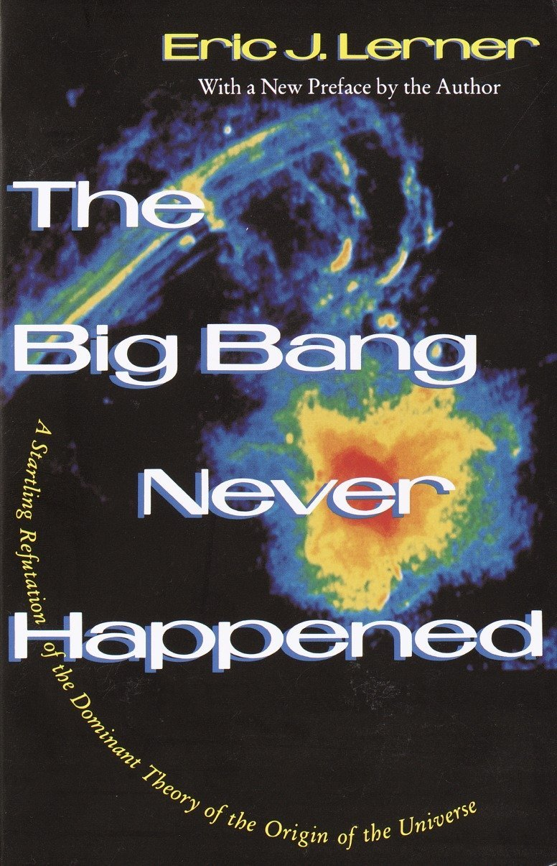
Why do the JWST’s images inspire panic among cosmologists? And what theory’s predictions are they contradicting? The papers don’t actually say. The truth that these papers don’t report is that the hypothesis that the JWST’s images are blatantly and repeatedly contradicting is the Big Bang Hypothesis that the universe began 14 billion years ago in an incredibly hot, dense state and has been expanding ever since. Since that hypothesis has been defended for decades as unquestionable truth by the vast majority of cosmological theorists, the new data is causing these theorists to panic. “Right now I find myself lying awake at three in the morning,” says Alison Kirkpatrick, an astronomer at the University of Kansas in Lawrence, “and wondering if everything I’ve done is wrong.” [Update: Kirkpatrick has protested Lerner’s handling of this quotation. See Note below.]
Eric J. Lerner, “The Big Bang didn’t happen” at IAI.TV (August 11, 2022)
Although we didn’t usually hear of it, there’s been dissatisfaction with the Standard Model, which begins with the Big Bang, ever since it was first proposed by Georges Lemaitre nearly a century ago. But no one expected the James Webb Space Telescope to contribute to the debate.
Now, Lerner is the author of a book called The Big Bang Never Happened (1992) but — while that makes him an interested party — it doesn’t make him wrong. He will be speaking at the HowTheLightGetsIn festival in London (September 17–18, 2022) sponsored by the Institute for Art and Ideas (IAI), as a participant in the “Cosmology and the Big Bust” debate.
The upcoming debate, which features philosopher of science Bjørn Ekeberg and Yale astrophysicist Priyamvada Natarajan, along with Lerner, is premised as follows:
The Big Bang theory crucially depends on the ‘inflation’ hypothesis that at the outset the universe expanded many orders of magnitude faster than the speed of light. But experiments have failed to prove evidence of cosmic inflation and since the theory’s inception it has been beset by deep puzzles. Now one of its founders, Paul Steinhardt has denounced the theory as mistaken and ‘scientifically meaningless’.
Do we have to give up the theory of cosmic inflation and seek a radical alternative? Might alternative theories like the Big Bounce, or abandoning the speed of light provide a solution? Or are such alternatives merely sticking plasters to avoid the more radical conclusion that it is time to give up on the Big Bang altogether?
Here’s a debate on this general topic from last year’s festival (but without JWST data). It features theoretical physicist Sabine Hossenfelder, author of Lost in Math: How Beauty Leads Physics Astray, along with Ekeberg and particle physicist Sam Henry.
So, yes, it’s been a serious topic of discussion for a while. Now, what to make of Eric Lerner’s approach? Experimental physicist Rob Sheldon offered Mind Matters News some thoughts and a potential solution:
The current thinking is that the Big Bang Nucleosynthesis era produced 75% Hydrogen and 25% Helium (by weight) and a smattering of Lithium, but not much else. Then after 300 thousand years, the universe cooled down enough to produce atoms, and gravitational attraction slowly, slowly built up stars. The early ones were big enough to explode, and the shock waves sent through the hydrogen gas caused pockets to form that began star-making in earnest. But it still took 500 million years to get enough stars for a galaxy. Now the earlier a galaxy forms, the further back in time and the further away it is from astronomers today, and the further away it is the faster it is moving away from us. This movement causes the light to be redshifted. So robust is this relationship, that astronomers replace “time” with “red-shift”. But the Hubble Space Telescope could only see visible light, and those early galaxies were so red-shifted they were only “visible” in the infra-red, which is where the James Webb telescope shines. So one of the goals of the James Webb telescope was to see the earliest galaxies, and indeed, they’re seeing a lot.
So what does this mean for the standard model?
Theorists have an answer. Lot’s of clumpy dark matter to get the Hydrogen gas to clump early. Which leads to the question, “why isn’t the dark matter clumpy now?”
I don’t have endurance to run down every rabbit trail cosmologists propose. Instead, I propose that the first stars were not made of Hydrogen, they were made of ice. The Big Bang synthesized abundant C and O which combined with H to form H20, CO2, CH4 etc. These gases freeze relatively early in the universe time frame, so clumping was not gravitational but physico-chemical, the same way snowflakes form. So we didn’t have to wait 500 million years for snowflakes to clump, it happen very quickly once the universe cooled below the freezing point. Hence James Webb sees lots of red-shifted galaxies from the early universe.
The paper on that (and maybe the prediction of what James Webb would find?) is in my open-access paper in Communications of the Blythe Institute in 2021.
That’s one possible solution. We know it’s science when it’s always posing challenges.
This sometimes comes up: Could the universe have always existed? The problem is, if the universe had existed for an infinite amount of time, everything that could possibly happen must already have happened an infinite number of times — including that we don’t exist and never did. But we know we do exist. As Robert J. Marks has pointed out, playing with infinity quickly results in absurdity. To do science, we must accept that some events are real and not mutually contradictory. So we can assume that the universe got started but we are a little less sure just now how that happened.
Note: In the wake of Lerner’s article, Kirkpatrick went onto her Twitter account to protest that Lerner misrepresented her statement to Nature about her “wondering if everything I’ve done is wrong.” Her current Twitter account name makes her view on a cosmic beginning clear: “Allison the Big Bang happened Kirkpatrick.” What is she questioning then? From the drift of the Nature article, it appears to be subsidiary theories within the larger Big-Bang tent—e.g., theories of galaxy evolution and, as she says, “the speed at which star formation occurs.” Clearly JWST has raised as many questions as it has provided answers – some quite intense.

